May Meeting at Lynville Observatory May 17th, 2019 @ 7:30pm
On August 13, 2017, the Next Generation Transit Survey (NGTS) telescope spotted an intense solar flare from a tiny star barely bigger than Jupiter. But despite this star’s diminutive size, the flare gave off as much energy as 80 billion megatons of TNT. That’s 10 times as powerful as the strongest flare ever observed on our own Sun. It’s also the coolest star ever observed to give off such a hot flare, and the spectacular outburst is teaching astronomers the power of small stars.

Photo by University of Warwick/Mark Garlick

Inside this Issue..
2 – Local Events and information
3 – News around the Globe
4 – Calendar
5 – EAS Minutes

The Evansville Astronomical Society (EAS) is a non-profit organization fully incorporated in the state of Indiana. It has, as its primary goal, the advancement of amateur astronomy. Founded in 1952, the society seeks to:

1… maintain adequate facilities for its members and the public in order to extensively study the skies and
2… promote an educational program for those who wish to learn more about the science of Astronomy.

Meetings are held the third Friday of each month, except June, when the annual EAS picnic is held. The society also sponsors monthly Open House events during the warmer seasons that afford the public an opportunity to tour the observatory.

EAS 2019 Officers and Contacts

President – Tony Bryan
812.827.3234
evansvilleastro@gmail.com

Vice President – Scott Conner

Secretary – David M Kube
740.223.6854

Treasurer – Ted Ubelhor

Counselors
Mitch Luman (2017)
Michael Borman (2018)
Ken Harris (2019)

Webmaster – Michael Borman

Program Director
Chuck Allen

Newsletter editor – Dave Kube
dasiceman@yahoo.com

For more information about the EAS or directions to the Observatory, please visit the club’s web page:
www.evansvilleastro.org

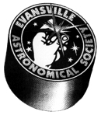

Local Events and Information
EAS Update:

Please Note we have a Regular Meeting scheduled at the Observatory on Friday, May 17th, 2019 @ 7:30pm.

Program: Dr. John Kielkopf, professor of astrophysics at the University of Louisville and director of its Walter Moore Observatory and its remote observing stations.

Dr. Kielkopf will be speaking about his exoplanet research using the university's three remotely-controlled planewave reflectors--a 20-inch in Kentucky, a 24-inch on Mt. Lemmon in Arizona, and a 27-inch on Mt. Kent in Australia.

EAS Update:

Please Note we have our EAS picnic & Observing Session scheduled for Saturday, June 8th. Time and Location TBD.
EAS Update:

Please Note we have our 3rd PSW scheduled at the Observatory on Saturday, June 22nd, 2019 @ 7:30pm.
EAS Update:

Please Note we have a Jupiter Watch scheduled at the Museum on Saturday, July 6th, 2019 from 8:30 to 10pm.
Please Note there is an “On the Moon Again” event at the Museum July 12th and 13th. This is an Event.
Please Note we have a Regular Meeting scheduled at the Observatory on Friday, July 19th, 2019 @ 7:30pm.
Please Note that our Stars on the Beach event at Patoka Lake is scheduled for Saturday, July 27th beginning at 11:00am Eastern Daylight Time.
FOR SALE:

Meade 8-inch Newtonian on heavy-duty LXD75 mount with AutoStar2 GoTo capability. Used very little. Asking $850.

Cave Astrola 10-inch f/15 Cassegrain on heavy-duty mount. Converts to an f/4 Newtonian. 10-inch Mathis RA drive gear. Asking $900.

Call Jim at 812-471-3017
Telescopes and accessories for sale...

As mentioned in last month’s issue, Mike Borman still has some excellent telescope equipment and imaging accessories for sale. Some of the gear has already been sold. If interested, go to Mike’s web page. Here is the link: http://www.mborman.org/forsale.htm
TESS Spacecraft Finds its First Earth-sized Planet Around Nearby Star. | The next generation of exoplanet hunting has arrived in the form of NASA’s Transiting Exoplanet and Survey Satellite. TESS looks at closer and brighter stars than Kepler, the spacecraft that first turned the trickle of exoplanet discoveries into a deluge. While TESS, which launched last year, is just beginning its sky search, it’s already started discovering new planets. Astronomers say they’ve discovered an Earth-sized planet dubbed HD 21749 c that  sits just 52 light-years from Earth and orbits its star every 8 days. It’s TESS’ first discovery of an Earth-sized planet.  Scientists also say they’ve confirmed HD 21749 b, a planet a little smaller than Neptune on a roughly 35-day orbit around the same star. Both TESS exoplanet findings were teased earlier this year.
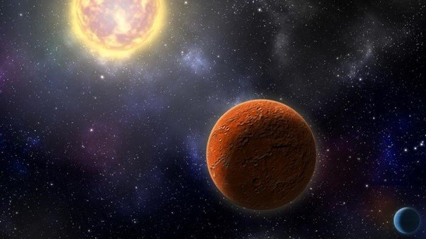
An artist’s illustration shows the two planets discovered circling nearby star HD 21749.

Robin Dienel/Carnegie Institution for Science
Merging Neutron Stars Gave Solar System Heavy Elements. | Before the planets in our solar system formed or the Sun turned on and started shining, two other stars had to die. Their deaths and later collision would seed the area where our area with many of the heavy materials needed for life on Earth. Now, 4.6 billion years later, astronomers are piecing together the story of these long-dead stars.  Stars have to make all the other elements in the universe in their nuclear fusion-powered cores. And even they stop when they reach the element iron, only 26th in order on the periodic table (elements are arranged from lightest, with the smallest number of protons, to heaviest, with the most). After that, everything we have comes from more exotic or extreme processes, like the explosion of a star at the end of its life – or the dramatic collision of one star with another. The former is much more common than the latter, at least when we’re talking about neutron stars, the dense cores of massive, dead stars. They make the most dramatic collisions, only slightly less energetic than two black holes colliding.  Neutron star mergers occur only a few times per million years in our galaxy (though we sometimes track them from  even further away via gravitational waves). By contrast, a new supernova explodes a few times per century somewhere in the Milky Way.  Researchers ran simulations of the Milky Way’s evolution, testing different histories of neutron star mergers and how they would affect the composition of our solar system today. They found that a single neutron star merger could have deposited a substantial amount of the heavy elements we have today by exploding less than 1,000 lightyears away from the dust cloud that would one day become our solar system.
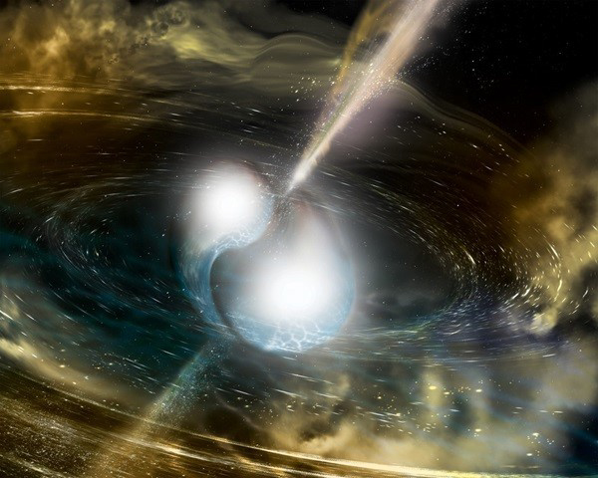
Colliding neutron stars might have seeded our solar system with valuable heavy elements.

NSF/LIGO/Sonoma State University/A. Simonnet

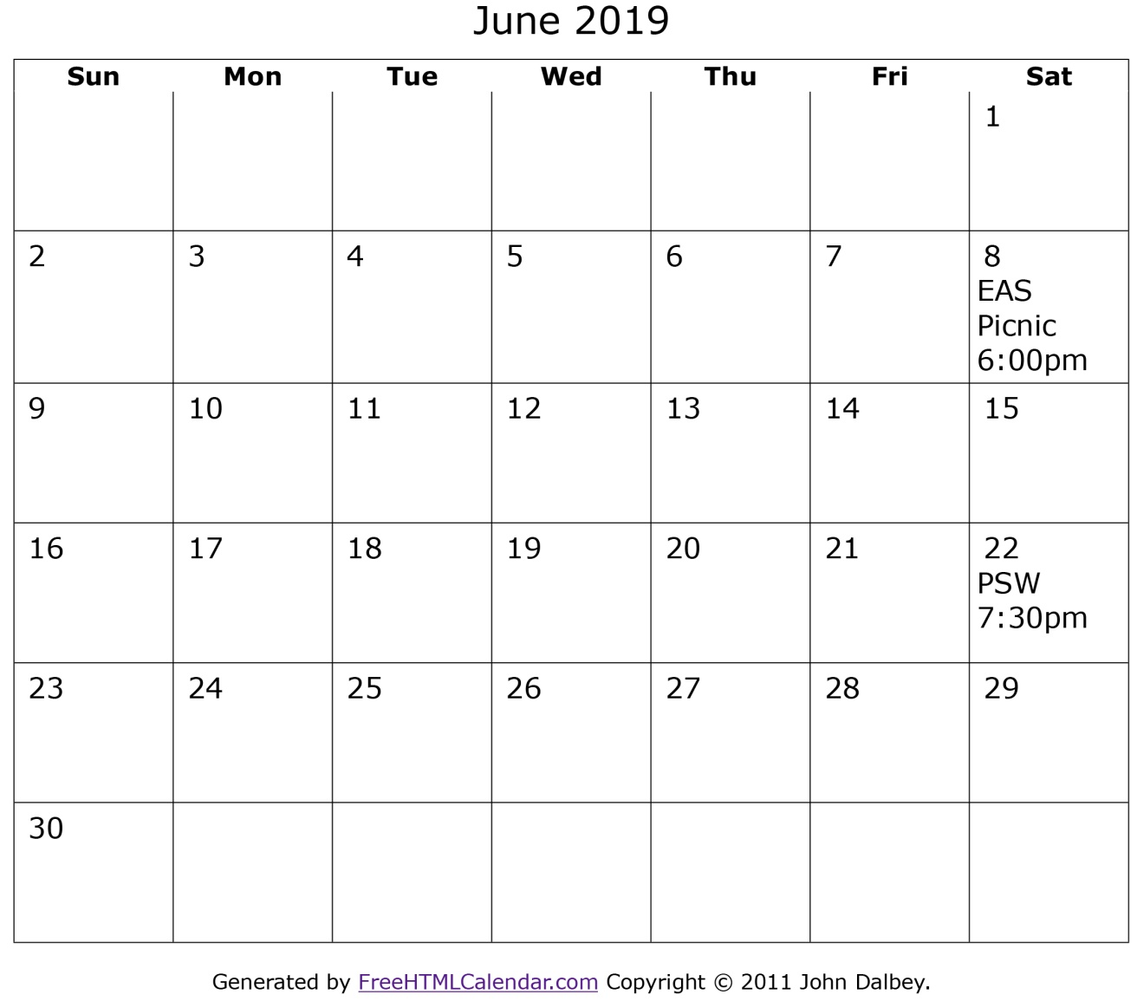

Up and Coming Events 2019
Regular Meeting – Friday, May 17th – @ Observatory @ 7:30 pm
EAS Picnic & Observing Session – Saturday, June 8th – Time/ Location TBD
PSW – Saturday, June 22nd – @ Observatory @ 7:30 pm
Jupiter Watch – Saturday, July 6th – @ Museum 8:30 – 10:00pm
On the Moon Again Outdoor Event – July 12 – 13th @ Museum
Regular Meeting – Friday, July 19th – @ Observatory @ 7:30 pm
Moon Phases
New Moon | First Quarter | Full Moon | Third Quarter
June 3rd, 2019 | June 10th, 2019 | June 17th, 2019 | June 25th, 2019
Moon Phases courtesy of Time and Date.com
EAS Meeting Minutes for April 19th, 2019

Minutes will be provided by Scott Conner on Monday May 13th, 2019 – The newsletter will be updated at that time.

